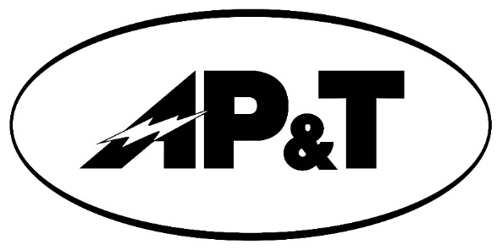

**Press Release**

**Project Update: Submarine Power Cable Replacement Project 2023 Construction—Haines and Skagway**

**April 26th, 2023**

**Contact:** Darren Belisle – Upper Lynn Canal Power Manager - [Darren.b@aptalaska.com](mailto:Darren.b@aptalaska.com)

The communities of Skagway and Haines are connected to each other, and to AP&T power generating stations, by a submarine power cable system. This system has distributed clean renewable hydroelectric power from AP&T projects to neighboring communities since 1998.

In 2019, AP&T encountered a failure of the fiber optic cable embedded in the segment connecting Skagway with the Kasidaya Hydroelectric Project. Although AP&T has redundant fiber facilities and communications were not interrupted, it was found the entire cable segment was at risk of failure. If the power transmission portion of this cable segment were to fail then Haines and Skagway utility systems would become isolated, impacting energy costs, decreasing reliability, and increasing fossil fuel used to generate community power.

AP&T is replacing the entire damaged segment between Skagway and Kasidaya this summer. The new Skagway landing will be constructed at Smuggler’s Cove.

Cable landing construction will begin in May.

Smuggler’s Cove work is scheduled for May 1 through June 24. To protect the public, access will be limited within the active construction zones. Smugglers Cove is a popular destination for people. We ask that you avoid the area as much as possible. We will shut down the trails at the construction site during active work times so please bear with us while crews work as swiftly and safely as possible to complete this important work. Please observe the posted warning signs and do not attempt to access the site.

Taiya Inlet submarine cable laying activities are scheduled for June 6 through June 14.

Construction should be completed by the end of June.

AP&T appreciates continuing community support for this project.